*Optical Sensors and Actuators*

*A report in MECE 614*

Ivan John A. Naparota

University of San Carlos – Talamban Campus

Department of Electrical and Electronics Engineering

ivanjohnnaparota66@gmail.com

**INTRODUCTION**

Optical sensors are electronic detectors that convert [light](https://en.wikipedia.org/wiki/Light), or a change in light, into an electronic signal. They are used in many industrial and consumer applications, for example, [lamps](https://en.wikipedia.org/wiki/Light_fixture) that turn on automatically in response to darkness, [position sensors](https://en.wikipedia.org/wiki/Position_sensor) that activate when an object interrupts a light beam, flash detection, to synchronize one [photographic flash](https://en.wikipedia.org/wiki/Photographic_flash) to another, [photoelectric sensors](https://en.wikipedia.org/wiki/Photoelectric_sensor) that detect the distance, absence, or presence of an object, capturing images in cameras, and many more. These numerous applications make the study of optical sensors and actuators significant.

**Photoelectric Effect**

This second quantum effect is the emission of electrons or other free carriers when light shines on a material, therefore it is governed by photons, the particle-like manifestation of radiation. In this representation of light, and in general radiation, energy travels in bundles (photons) whose energy is given by Plank’s equation:

**e = hf**

Where:

h = 6.6262x10-34 J/s or 4.1357x10-15 eV

f = frequency in hertz

e = photon energy

Any excess energy imparts the electron kinetic energy. This theory was first postulated by Albert Einstein in his photon theory, which he used to explain the photoelectric effect in 1905 (and for which he received the Nobel Prize). This is expressed as:

**hf = e0 + k**

Where:

e0 = work function and is the energy required to leave the surface of the material (see Table 4.2)

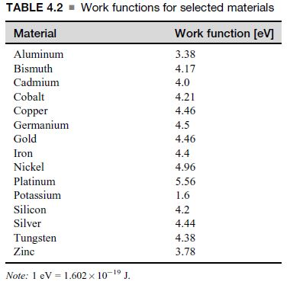k = mv2/2 (represents the maximum kinetic energy the electron may have outside the material)

A photon with energy higher than the work function will, in principle, release an electron and impart a kinetic energy according to the equation. But does in fact each photon release an electron? That depends on the quantum efficiency of the process.

Quantum efficiency is the ratio of the number of electrons released (Ne) to number of photons absorbed (Nph):



Typical values are around 10% – 20%. This simply means that not all photons release electrons.

**Example:**

Consider a photoelectric device intended for light detection.

a. Assuming it is made of a potassium-coated surface, what is the lowest wavelength that the device can detect?

b. What is the kinetic energy of an emitted electron under red light radiation at a wavelength of 620 nm?

**Solution:**

**a.)**

hf = e0

f = e0 / h [Hz]

Note:

f = c / λ [Hz]

Where:

c = speed of light

λ = wavelength

λ = ch / e0

= 3 x 108 x 4.1357 x 10-15 / 1.6

= 7.7544 x 10-7 m or 775.44 nm

**b.)**

f = c/λ

k = hf - e0

= 4.1357 x 10-15 x (3 x 108 / 620 x 10-9) – 1.6

= 0.4 eV

**Photoelectric Sensor**

How it works?

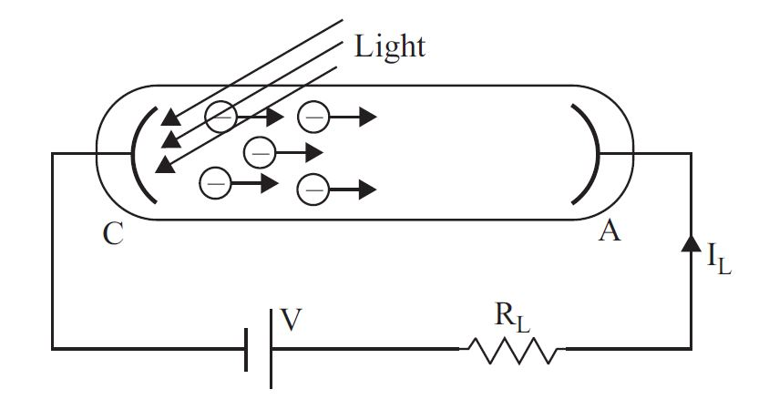

The photocathode is made of a material with relatively low work function to allow efficient emission of electrons. These electrons are then accelerated toward the photoanode because of the potential difference between the anode and cathode. The current in the circuit is then proportional to radiation intensity.

**Photomultipliers**

Photomultipliers are a development of the classical photoelectric sensor. Whereas in a photoelectric sensor the current is low (the number of electrons emitted is small), photomultipliers, as their names imply, multiply the available current, resulting in sensors that are considerably more sensitive than the simple photoelectric cell.

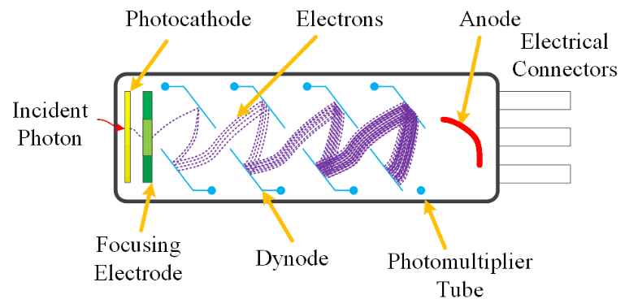

**Formulas:**

Current Gain

G = nk

Where:

n = the average number of electrons emitted per dynode

k = number of dynodes

Dark Current



a = constant depending on the material of the cathode (generally around 0.5)

A = 120.173 A/cm2

T = absolute temperature

Eo = work function of the cathode material (eV)

k = Boltzmann’s constant

**Example:**

A photomultiplier with 10 dynodes has a cathode coated with potassium to increase sensitivity. Calculate the thermally produced dark current at the cathode and at the anode at 25C, assuming that each incoming photon is energetic enough to release six electrons and that each accelerated electron releases six electrons.

**Solution:**

**Cathode**

The work function of potassium is 1.6 eV (see **Table 4.2**). Room temperature is 273.15 + 25 = 298.15oK. With the Boltzmann constant, k = 8.62 x 10-5 eV/oK, we get

I0 = aAT2e-Eo/kT

= 0.5 x 120.173 x 104 x (298.15)2

= 4.9 x 10-17 A or 4.9 x 10-8 nA

**Anode**

G = nk = 610 = 6.05 x 107

Ia = 4.9 x 10-17 x 6.05 x 107

= 2.96 x 10-9 A or 3 nA

**Coupled Charge Device (CCD) Sensors**

What happened in each pixel?

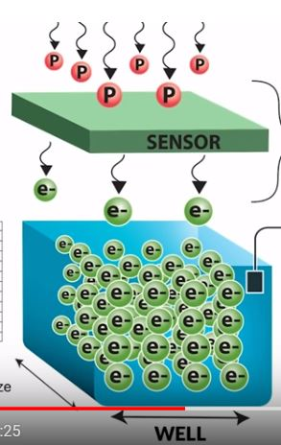

The light or the photon strikes the sensor that will cause in the release of electrons, the number of electrons is therefore directly proportional to the intensity of light that struck the sensor.

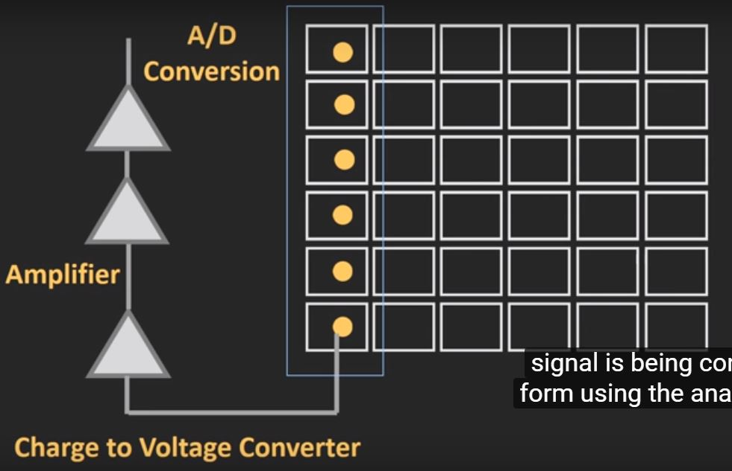

Each pixels are now then processed column by column. The process goes like this, it is converted into voltage and amplified afterwards so that it can be converted from analog to digital signal that will be decoded later on.

**Passive Infrared Sensor**

A PIR sensor has two basic components: an absorption section that converts radiation into heat and a proper temperature sensor that converts heat into an electrical signal.

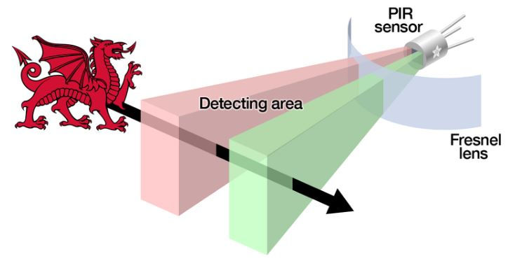

**Thermopile PIR**

It has the same concept with thermocouple that was already discussed in the previous ch­apters. As you can see in below’s diagram, ­­­it is composed of a number of thermocouples.

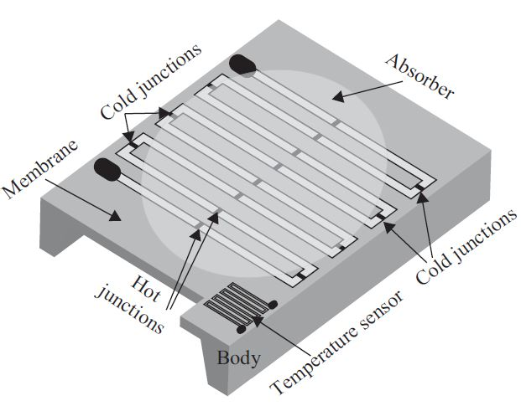

**Pyroelectric Sensor**

The pyroelectric effect is an electric charge generated in response to heat flow through the body of a crystal.

Formulas:

**Charge**



A = area of the sensor

Pq = constant depending on the material, see Table 4.4

**Voltage**



Pv = its pyroelectric voltage coefficient, see Table 4.4

h = thickness of the crystal

**Capacitance**

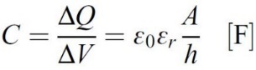

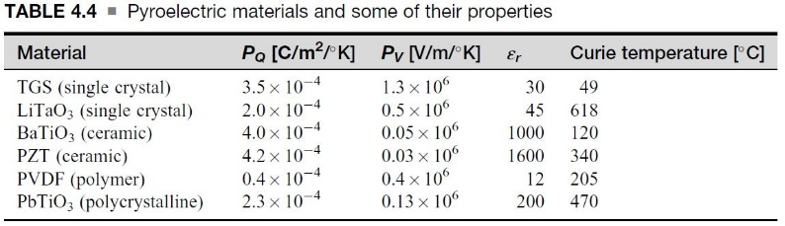

**Example:**

A motion sensor based on a PZT ceramic is used to turn on lights in a room as a person enters the room. The sensor is made of two conducting plates with a PZT chip (8 mm wide 10 mm long 0.1 mm thick) between them, forming a capacitor. One plate is exposed to the motion, whereas the other is connected to the body of the sensor and held at its temperature. As the person enters the room, the person’s body temperature causes the exposed plate’s temperature to temporarily rise by 0.01C because of the IR radiation produced by the body. This temperature dissipates and eventually both plates will reach the same steady-state temperature. For this reason the sensor can detect motion but not presence. Calculate the charge produced on the plate and the potential difference across the sensor due to the rise in temperature.

**Solution**

∆V = (PQ x h / e0er) ∆T

= 4.2 x 10-4 x (0.1 x 10-3/1600 x 8.854 x 10-12)

(0.01)

= 0.0296 V

C = e0erA/h

= (1600 x 8.854 x 10-12 x 0.008 x 0.01) / 0.1 x 10-3

= 1.1333 x 10-8 F

∆Q = C∆V

= 1.1333 x 10-8 x 0.0296

= 3.355 x 10-10 C

**Bolometers**

The radiation is absorbed by the device directly, causing a change in its temperature. This temperature increase is proportional to the radiated power density at the location of sensing. This change causes a change in the resistance of the sensing element that is then related to the power or power density at the location being sensed.

The sensitivity of a bolometer to radiation can be written as follows:

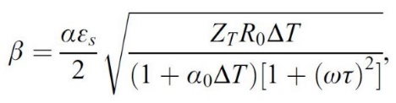

αs = is a loss coefficient or thermal conductivity

Ts = the sensor’s temperature

Ta = the ambient temperature

*Sensed Temperature*

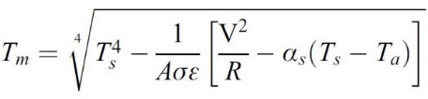

Where:

σ = electric conductivity of the sensor medium.

**ACKNOWLEDGEMENT**

The reporter would like to thank Engr. Joseph Karl Salva for imparting his knowledge to the reporter.

**REFERENCE**

“Sensors, Actuators, and their Interfaces”, Nathan Ida